**Project Design Phase-II Data Flow Diagram &User Stories**

|  |  |
| --- | --- |
| Date | 13 October 2022 |
| Team ID | PNT2022TMID30346 |
| Project Name | Project - AI-based localization and classification of skin disease with Erythema |
| Maximum Marks | 4 Marks |

# Data Flow Diagrams:

A Data Flow Diagram (DFD) is a traditional visual representation of the information flows within a system. A neat and clear DFD can depict the right amount of the system requirement graphically. It shows how data enters and leaves the system, what changes the information, and where data is stored.

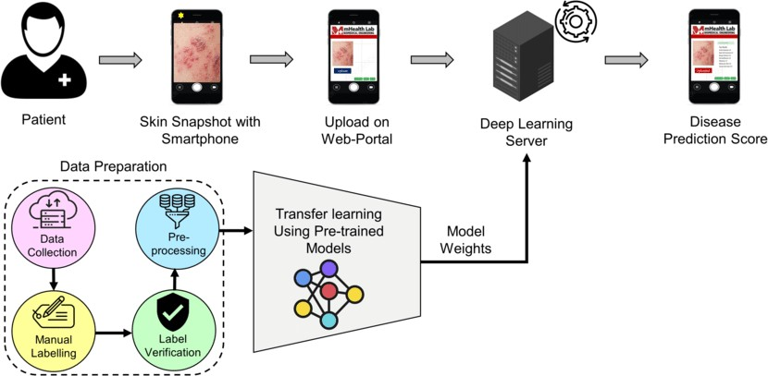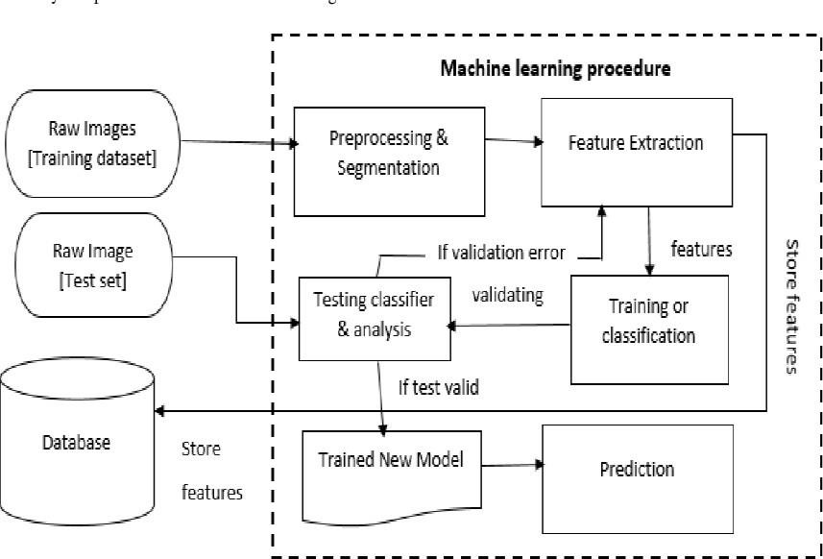

# User Stories

Use the below template to list all the user stories for the product.

|  |  |  |  |  |  |  |
| --- | --- | --- | --- | --- | --- | --- |
| **User Type** | **Functional Requirement (Epic)** | **User Story Number** | **User Story / Task** | **Acceptance criteria** | **Priority** | **Release** |
| Customer (Mobile user) | Registration | USN-1 | As a user, I can register for the application by entering my email, password, and confirming my password. | I can access my account / dashboard | High | Sprint-1 |
|  |  | USN-2 | As a user, I will receive confirmation email  once I have registered for the application | I can receive confirmation  email & click confirm | High | Sprint-1 |
|  |  | USN-3 | As a user, I can register for the application through Facebook | I can register & access the  dashboard with Facebook Login | Low | Sprint-2 |
|  |  | USN-4 | As a user, I can register for the application through Gmail. |  | Medium | Sprint-1 |
|  | Login | USN-5 | As a user, I can log into the application by entering email & password |  | High | Sprint-1 |
|  | Dashboard | USN-5 | As a user, I can Access my Dashboard. |  | Medium | Sprint-3 |
| Customer (Web user) | Registration | USN-1 | As a user, I can register for the application by entering my email, password, and confirming my password. | I can access my account / dashboard | High | Sprint-4 |
| Customer Care | Solution | USN-5 | Responding to each email you receive can | Offer a solution for how | High | Sprint-3 |
| Executive | make a lasting impression on customers. | your company can |
|  |  | improve the customer's |
|  |  | experience. |
| Administrator | Manage | USN-5 | Do-it-yourself service for delivering Everything. | set of predefined requirements that must be met to mark a user story  complete. | High | Sprint-4 |